**抑郁问卷的异质性：基于对27个抑郁测量问卷的内容分析**

汪浩远1, 胡孟真1, 田柳青1, 刘伟彪1, 安媛媛1, 李瑛2, 胡传鹏1#

(1南京师范大学心理学院; 2首都医科大学附属北京儿童医院精神科)

**Assessing the heterogeneity of 27 scales for measuring depression**

Haoyuan Wang, Mengzhen Hu, XXX

**CrediT Author Statement**

**Wang Hao Yuan：**Conceptualization, Data curation, Investigation, Writing - Original Draft. **Hu Meng Zhen：**Data curation, Visualization, Investigation. **Tian Liu Qing:** Investigation. **Liu Wei Biao:** Investigation. **Yuanyuan An:** Writing- Reviewing and Editing. **Ying Li:** Writing- Reviewing and Editing. **Hu Chuan-Peng：**Supervision**,** Project administration, Writing- Reviewing and Editing.

Corresponding author: Hu Chuan-Peng, email: hcp4715@hotmail.com

JAMA Network Open

Asian Journal of Psychiatry

看看编辑投稿风格

摘要

关键词

# 1. 引言

[抑郁障碍的严重性（患病率、社会成本等），青少年期和成年早期是关键的时间。]

[上述关于抑郁障碍的患病率大部分来自于自评量表，在抑郁症的研究中广泛使用，也是各类关于青少年与学生政策的基础（中国、世界范围内大规范调查的的数据）。]

[但作为解决抑郁问题第一步的测量与诊断问题，目前较为忽视，列举Fried的工作。不同抑郁问题可能在测量不同的内容。Fried（2017年）的研究表明，不同的抑郁量表不能互相替代使用，这给抑郁研究带来了挑战。]

[在中国，同样存在着抑郁自评量表数量繁多，被广泛使用的量表也不在少数，有潜在的重大影响（如影响到心理健康问题的检出率）。]

[本研究准备怎么做]

|  |  |  |
| --- | --- | --- |
| 国民抑郁症蓝皮书 | 未知 |  |
| 中国国民健康心理发展报告 心理所 | Cesd |  |
| 2021和2022年中国居民抑郁和焦虑症状及其共患的相关因素 |  | 知网自行查找 |
| Prevalence of depressive disorders and treatment in China:  a cross-sectional epidemiological study  中华人民共和国国家卫生健康委员会和科学技术部。 |  | 传鹏10.9 |
| Age of onset and cumulative risk of  mental disorders: a cross-national analysis  of population surveys from 29 countries |  | 传鹏8.11 |
| Time for united action on depression: a  Lancet-World Psychiatric Association  Commission |  | 传鹏8.3 |
|  |  |  |

# 2. Methods

We took three steps to extract symptoms from all scales that measure depressions among the Chinese students population (see Fig 1 for the flowchart). Firstly, we identified all scales that has been used for screening depression. Secondly, we identified unique symptoms of each scale. Thirdly, we compared the symptoms across all scales. The latter two steps followed Fried (2017) but with modifications (see details below).

## 2.1 Identify and screen scales

We identified scales that measure depression from four recent meta-analyses which synthesized the prevalence of different mental health problems among four Chinese students populations: elementary school, middle school, high school, and college (于晓琪等, 2022; 黄潇潇等, 2022; 张亚利等, 2022; 陈雨濛等, 2022). We extracted all papers included in these meta-analyses and selected scales that were used for screening depression. In total, we identified 34 scales from 470 articles from all articles included in these four meta-analysis.

We then screened versions of scales and identified the most valid version for later analysis (See supplementary material for details). If a scale has multiple versions, we choose one of these version based on the following criteria: (1) If the reference(s) of the scale cited in articles was in English, we search for the Chinese versions because all participants in the above mentioned articles are Chinese students; (2) If the reference(s) of the scale included both English and Chinese versions of the scale, we included the Chinese version; (3) If there were multiple Chinese versions and the latter one(s) improved the previous ones for methological reasons, we choosed the latter version; (4) If there were multiple Chinese versions and no obvious methodological advances were reported, we included the one explicitly stated symptom names; (5) If all other condition were equal, we selected the most frequently cited one. For instance, CES-D was first translated by 汪向东等(1999), which was used by 39 of all 470 papers included in the four menta-analyses. However, 章婕等(2010) improved the translation of the 20th item, thus, we chose the revised version by 章婕等(2010).

## 2.2 Identify symptoms within scales

In this phase, four trained coders focused on identifying items that assessed identical or similar symptoms within each scale. The process proceeded as follows: First, the four coders independently identified and consolidated items within each scale. Then, they formed two pairs, with each pair reviewing their results and resolving any discrepancies. Subsequently, the two pairs of coders cross-checked their findings and collaboratively addressed any remaining inconsistencies, seeking guidance from the corresponding author when necessary. The final, consolidated version of the results underwent independent verification by a clinically certified doctor (co-author ***), who made necessary revisions to ensure accuracy.

## 2.3 Compare symptoms across different scales

In this step, the same four coders compared symptoms across all scales. The procedure was the same as the identification of symptoms within scales: indepenedent individual coding, discussion by pairs, cross-checking between pairs, discussion with the corresponding author, and verification by a clinically certificated doctor.

The coding processes were as follow. We first pooled symptoms from all scales together and identified unique symptoms. In this step, we retained both compound symptoms and specific symptoms, as in Fried (2017). Compound symptoms are symptoms that include a range of related symptoms, whereas specific symptoms are more concrete and describe specific patterns. For example, “appetite changes” is a compound symptom, it includes two specific symptoms: “appetite increased” and “appetite decreased”. And all three symptoms were treated as unique symptoms. We employed an approach that maximize the amount of different symptoms. More specifically, if the items describe similar symptom using different words and that the words have significantly different meanings under the Chinese context, we treat them as belonging to the same compound symptom but are different specific symptoms. For instance, there are many different words for describe depressed mood in different scales, we used 'depressed moods' as the compound symptom but distinguish different specific symptoms such as: 'blue', 'low mood', 'sad', and 'anhedonia'. This approach is slightly different from Fried (2017), where he coded all these item as a specific symptom 'Sad moods'.

Then, we coded each scale on all unique symptoms. More specifically, a scale was coded as “0” on a symtom if it does not have items that measures this symptom. If a scale has an item that directly measures a symptom, compound or specific, it was coded as 2 on that symptom. Note if a scale has an item measures a compound symptom, then, this scale not only had a score of 2 on that compound symptom but also has a score of 1 on each of the specific symptoms under this compound symptom. For instance, the CDI has no item for 'Depressed mood' , we assigned “0” for CDI on this symptom. For compound symptom “appetite change”, CDI has an item directly measures this symptom and was coded as 2 on this symptom. Importantly, even CDI does not have item for specific symptoms of “appetite changes”, i.e., 'appetite increased' and 'appetite decreased', it was coded as 1 on both two specific symptoms (see Supplementary Materials and Figure 2 for details). However, if the item measures a specific symptom under a compound symptom, this scale was coded “2” on that specific symptom but also coded as “0” on the corresponding compound symptom.

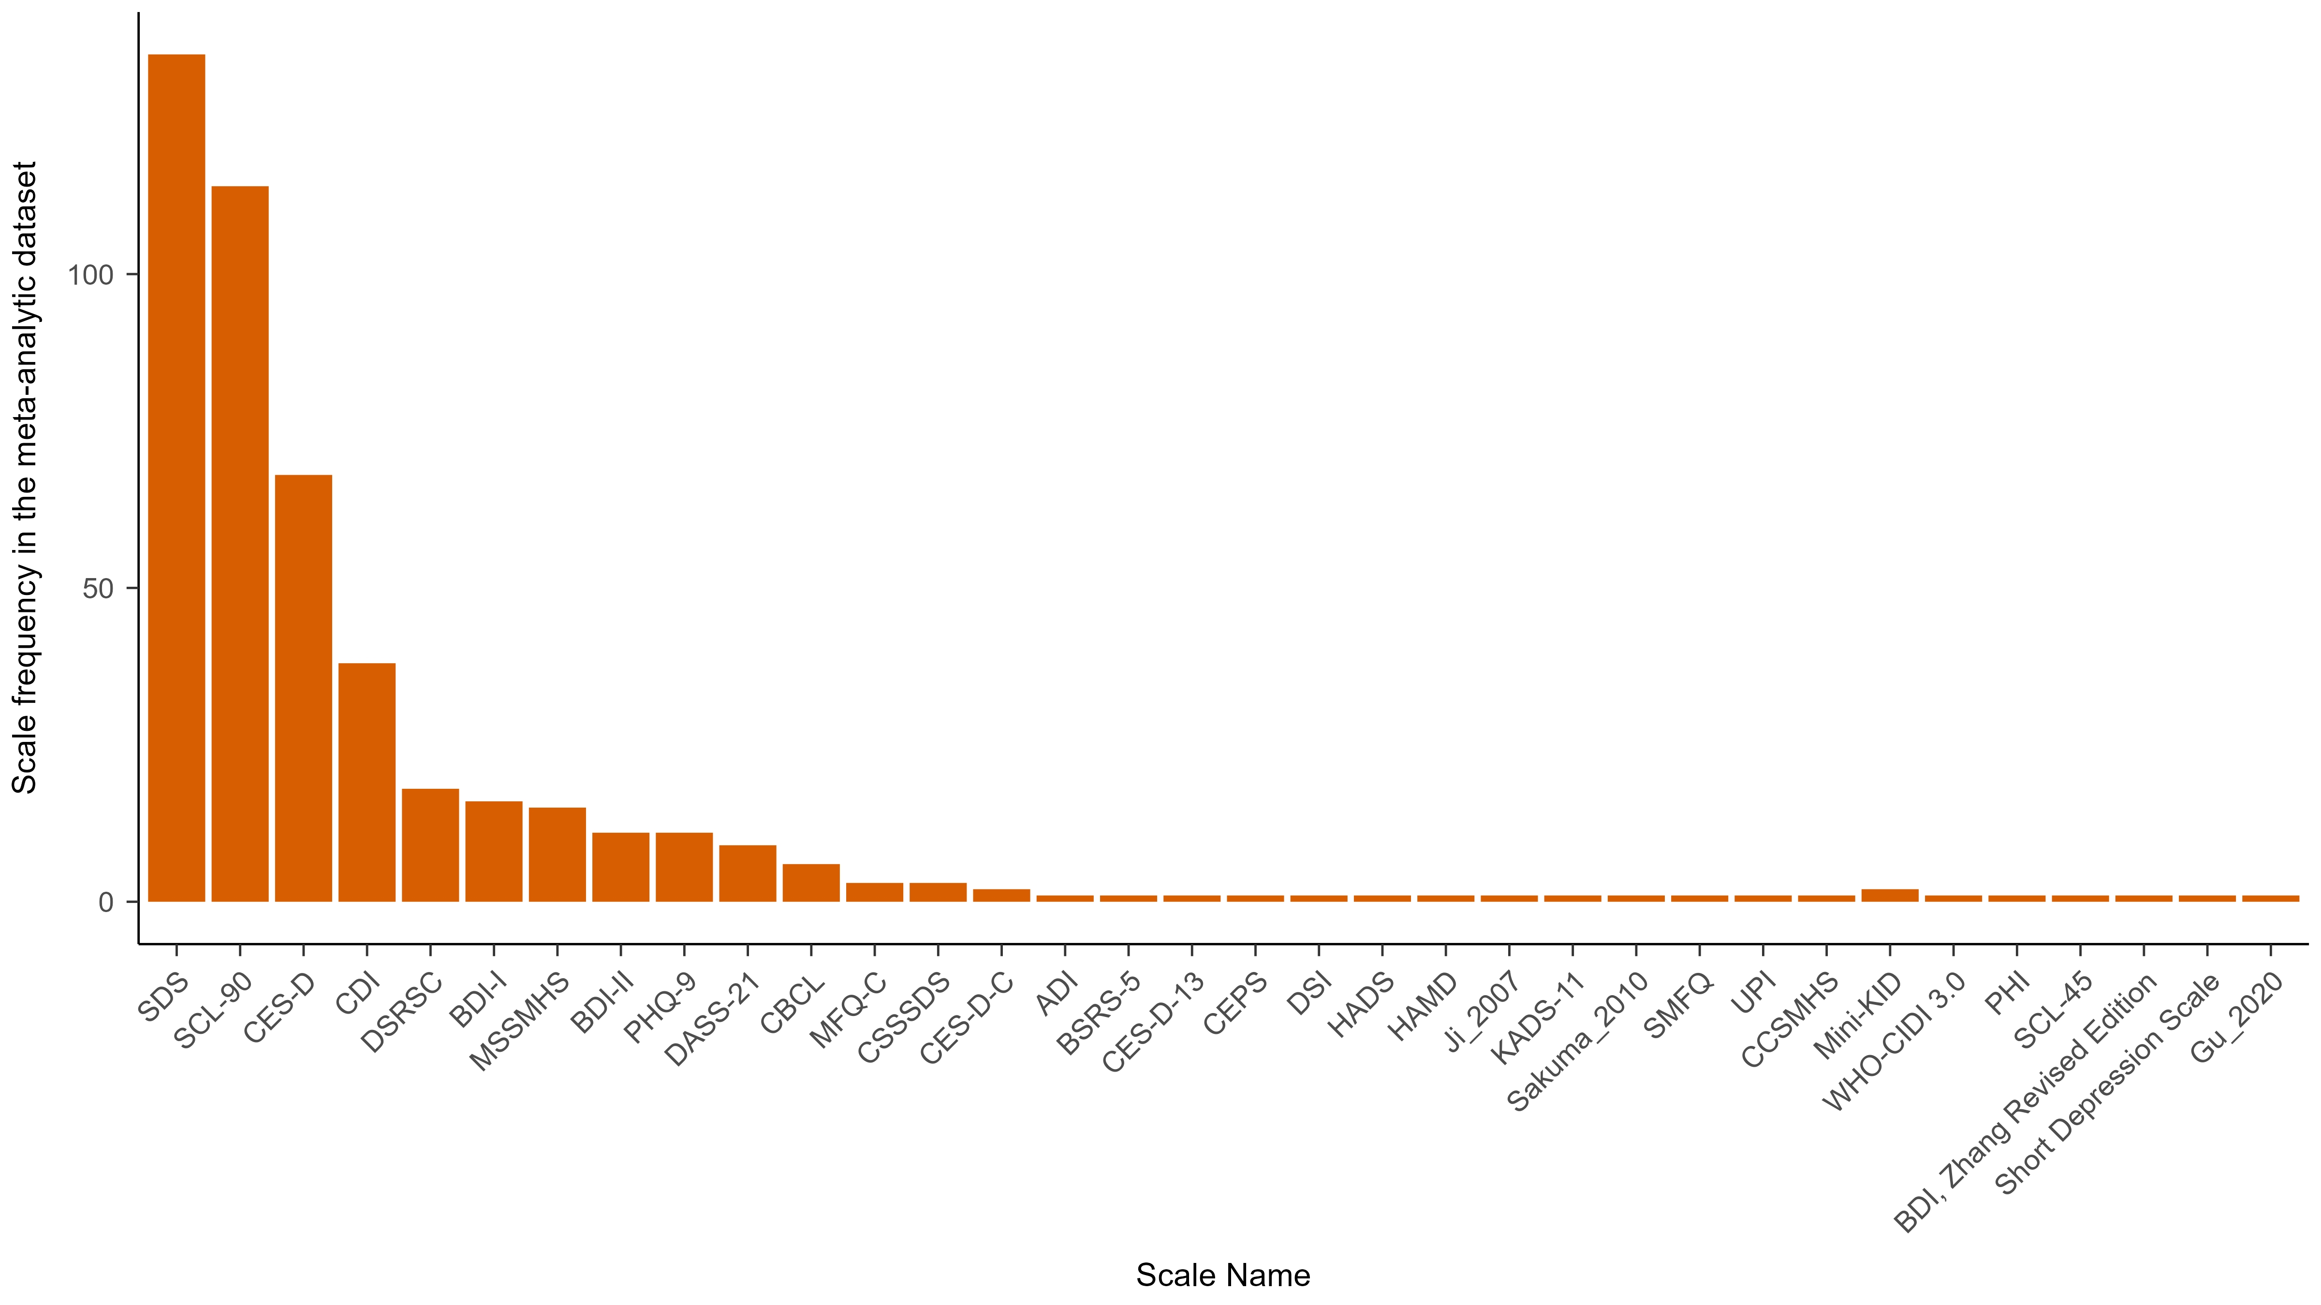

**Figure 2***.Number of articles that used each scale for screening depression.* Total number of articles were based on those included in four meta-analyses (XXX). Scales with * were excluded from our analyses.

## 2.4 Data analyses

We reported the descriptive summary of scales as well as the symptoms within scale. We also highlightd symptoms that are used in DSM-5 for diagonosis of depression. More specifically, there are 28 symptoms are DSM-5 symptom, derived from the nine symptoms in DSM-5 and all their specific symptoms, see Fried & Nesse, (2015) for details.

We analyzed shared and distinct symptom across scales. We used Jaccard index for the degree of overlap between different scales (Fried, 2017). The formal of Jaccard index is s/(u1 + u2 + s), where "s" represents the number of items shared by two scales, and "u1" and "u2" denote the number of items that are exclusively present in each of the two scales. Jaccard index ranges from 0 (no overlap among scales) to 1 (complete overlap). We interpreted Jaccard index as in Fried (2017) guidelines: very weak 0.00–0.19, weak 0.20–0.39, moderate 0.40–0.59, strong 0.60–0.79, and very strong 0.80–1.0. We explored the relationship between the mean Jaccard coefficient and the scale length across 27 scales by employing Pearson correlation.

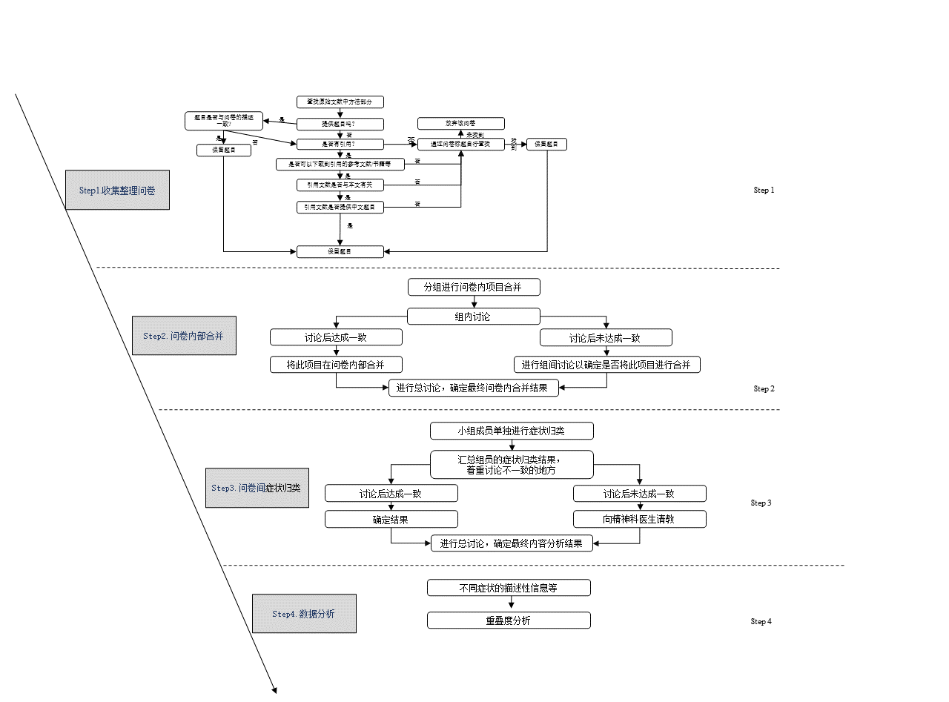

**Figure 1**

*Research flowchart*

# 3 Result

# 3.1 A summary of scales

Among all papers included in these four meta-analyses (citations), 470 reported depression. We identified 34 unique scales in these articles. Among all these scales, the items of four scales, the Mini International Neuropsychiatric Interview for children and adolescents (Mini-KID), WHO-CIDI 3.0, Psychological Health Inventory (PHI), and the Symptom Checklist 45, were not findable. The items of the other two scales, the Beck Depression Inventory (Zhang Yuxin Revised Edition) and Short Depression Scale, were not available either because of unidentifiable citations. These six scales were excluded from furthere analyses. The items used in 'Gu & Chen (2020) 'and 'Ji (2007)' were identifical but in different languages, thus we regarded these two studies used the same scale referred them as 'Ji (2007)'. Also, the boys’ and girls’ version of the Child Behavior Checklist (CBCL) were treated as one scale, CBCL. In short, 27 scales were included in the current study. See figure 2 for the number of usages of these scales among all 470 empirical papers in the meta-analyes (CITATIONS). The seven most frequently used scales in this study are SDS, SCL-90, CES-D, CDI, DSRSC, BDI-I, and MSSMHS, among which CES-D and SDS are consistent with the scales selected by Fried (2017).

# 3.2 Items and symptoms within scales

For the 27 scales included, there are 425 items in total. We merged 73 items into 31 symptoms when coding items within scales. Also, there were two cases where one item measured two symptoms. The item from Ji (2007), "During the past 12 months, did you ever feel so sad or hopeless almost every day for two weeks or more in a row that you stopped doing your usual activities?" meausres both 'sad' and 'Sense of hopelessness'. And the 8th item from PHQ-9, "Actions or speech slowed down to a noticeable extent, or conversely—feeling restless or agitated, being unable to sit still, more than usual", measures both 'Agitation' and 'Retardation'. Thus, a total of 385 symptoms were identified across different scales (See supplementary materials for number of items and symptoms of each included scale).

The comparison of 385 symptoms across 27 scales resulted in unique 84 symptoms (see Figure 3). Among these, eight are compound symptoms, including *Depressive mood, Irritability*, *Self-abasement*, *Interest/pleasure loss*, *Somatization*, *Appetite changes*, *Somnipathy*, and *Reduced socialization* (See supplementary material for details). Among all 27 scales, 19 of them did not include any idiosyncratic symptoms. For the other eight scales the rate of idiosyncratic symptom varied from 3.9% to 22.2%. Interestingly, all scales include symptoms that were not used for diagnosis of depression in DSM-5. Among them, DSI has the highest proportion of DSM-5 symptoms for depression, 71.42% of the total nine DSM-5 depression symptoms. Please see the supplementary matierals for detailed information.

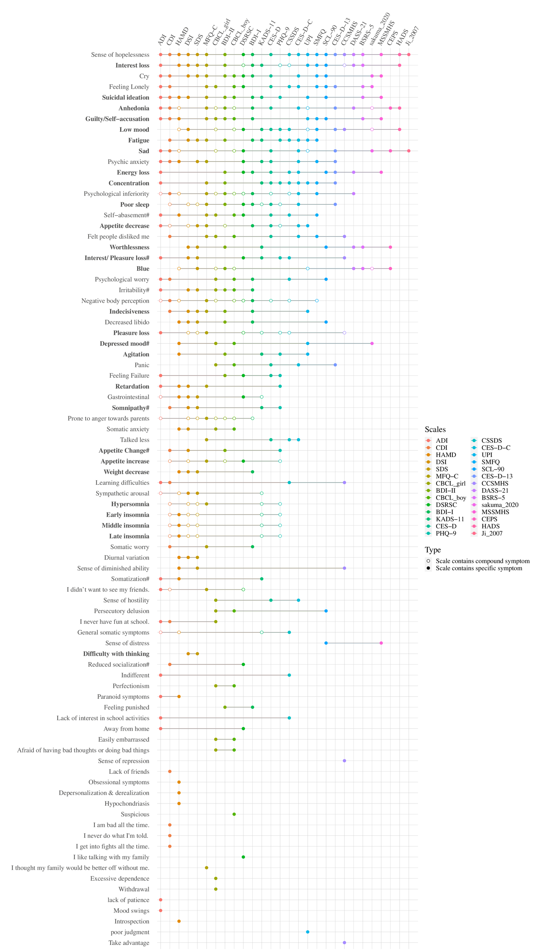

**Figure 3***. Content Overlap Across* *Twenty-seven Depression Scales.* Each row represents a symptom, each column represents a scale.If a scale measures a symptom, then there is a dot or a circle on that row. The former represent compound symptoms and the latter represent specific symptoms. Symptoms in bold font are from DSM-5. ADI: Adolescent Depression Inventory, CDI: Children's Depression Inventory, HAMD: Hamilton Depression Rating Scale for Depression, DSI: Depression Status Inventory, SDS: Self- Rating Depression Scale, MFQ-C: Mood and Feelings Questionnaire, CBCL: Child Behavior Checklist, BDI-II：Beck Depression Inventory-II, DSRSC: Depression Self-rating Scale for Children, BDI-I: Beck Depression Inventory, KADS-11: Kutcher Adolescent Depression Scale, CES-D: The Center for Epidemiological Studies Depression Scale, PHQ-9: Patient Health Questionnaire-9 items, CSSDS: China Middle school students' depression scale, CES-D-C: Center for Epidemiologic Studies Depression Scale for Children, UPI: University Personality Inventory, SMFQ: Short Mood and Feelings Questionnaire, SCL-90: Symptom Checklist 90, CES-D-13: Short version of Center for Epidemiologic Studies Depression Scale, CCSMHS: Chinese College Student Mental Health Scale, DASS-21: The Depression Anxiety Stress Scale, BSRS-5: Brief Symptom Rating Scale, Sakuma_2010: Sakuma et al.(2010) self-designed questionnaire, MSSMHS: Middle-school students Mental Health Scale, CEPS: China Education Panel Survey, HADS: Hospital Anxiety and Depression Scale, Ji_2007: Comprehensive Survey Report on Health-Related/Risk Behaviors among Chinese Adolescents.

# 3.3 Symptoms across scales

Among the 84 symptoms, 18 (21.43%) were idiosyncratic symptoms and only appeared in one scale. None of the symptoms were present on all scales. The most frequently symptom, appeared in 22 out of 27 scales, was *Sense of hopelessness*. The second most measured symptom, 18 out of 27, was *Interest loss*. Note that *markedly diminished interest or pleasure*, a key symptom of diagnosis of major depression in DSM-5, is splitted into two specific symptoms: *interest loss* and *pleasure loss* in this study*.* We found *Pleasure loss* was observed less frequently than *Interest loss*, being measured in 9 out of 27 scales. Another frequently measured symptom is the compound symptom *Depressed mood*, which was directly measured in 5 scales. However, this compound symptom include several specific symptoms: *blue* appeared in 10 scales, *low mood* in 15 scales, *sad* in 13 scales, and *anhedonia* in 16 scales*.* Combined as a cluster, depressed mood and related specific symptom are the most frequently measured.

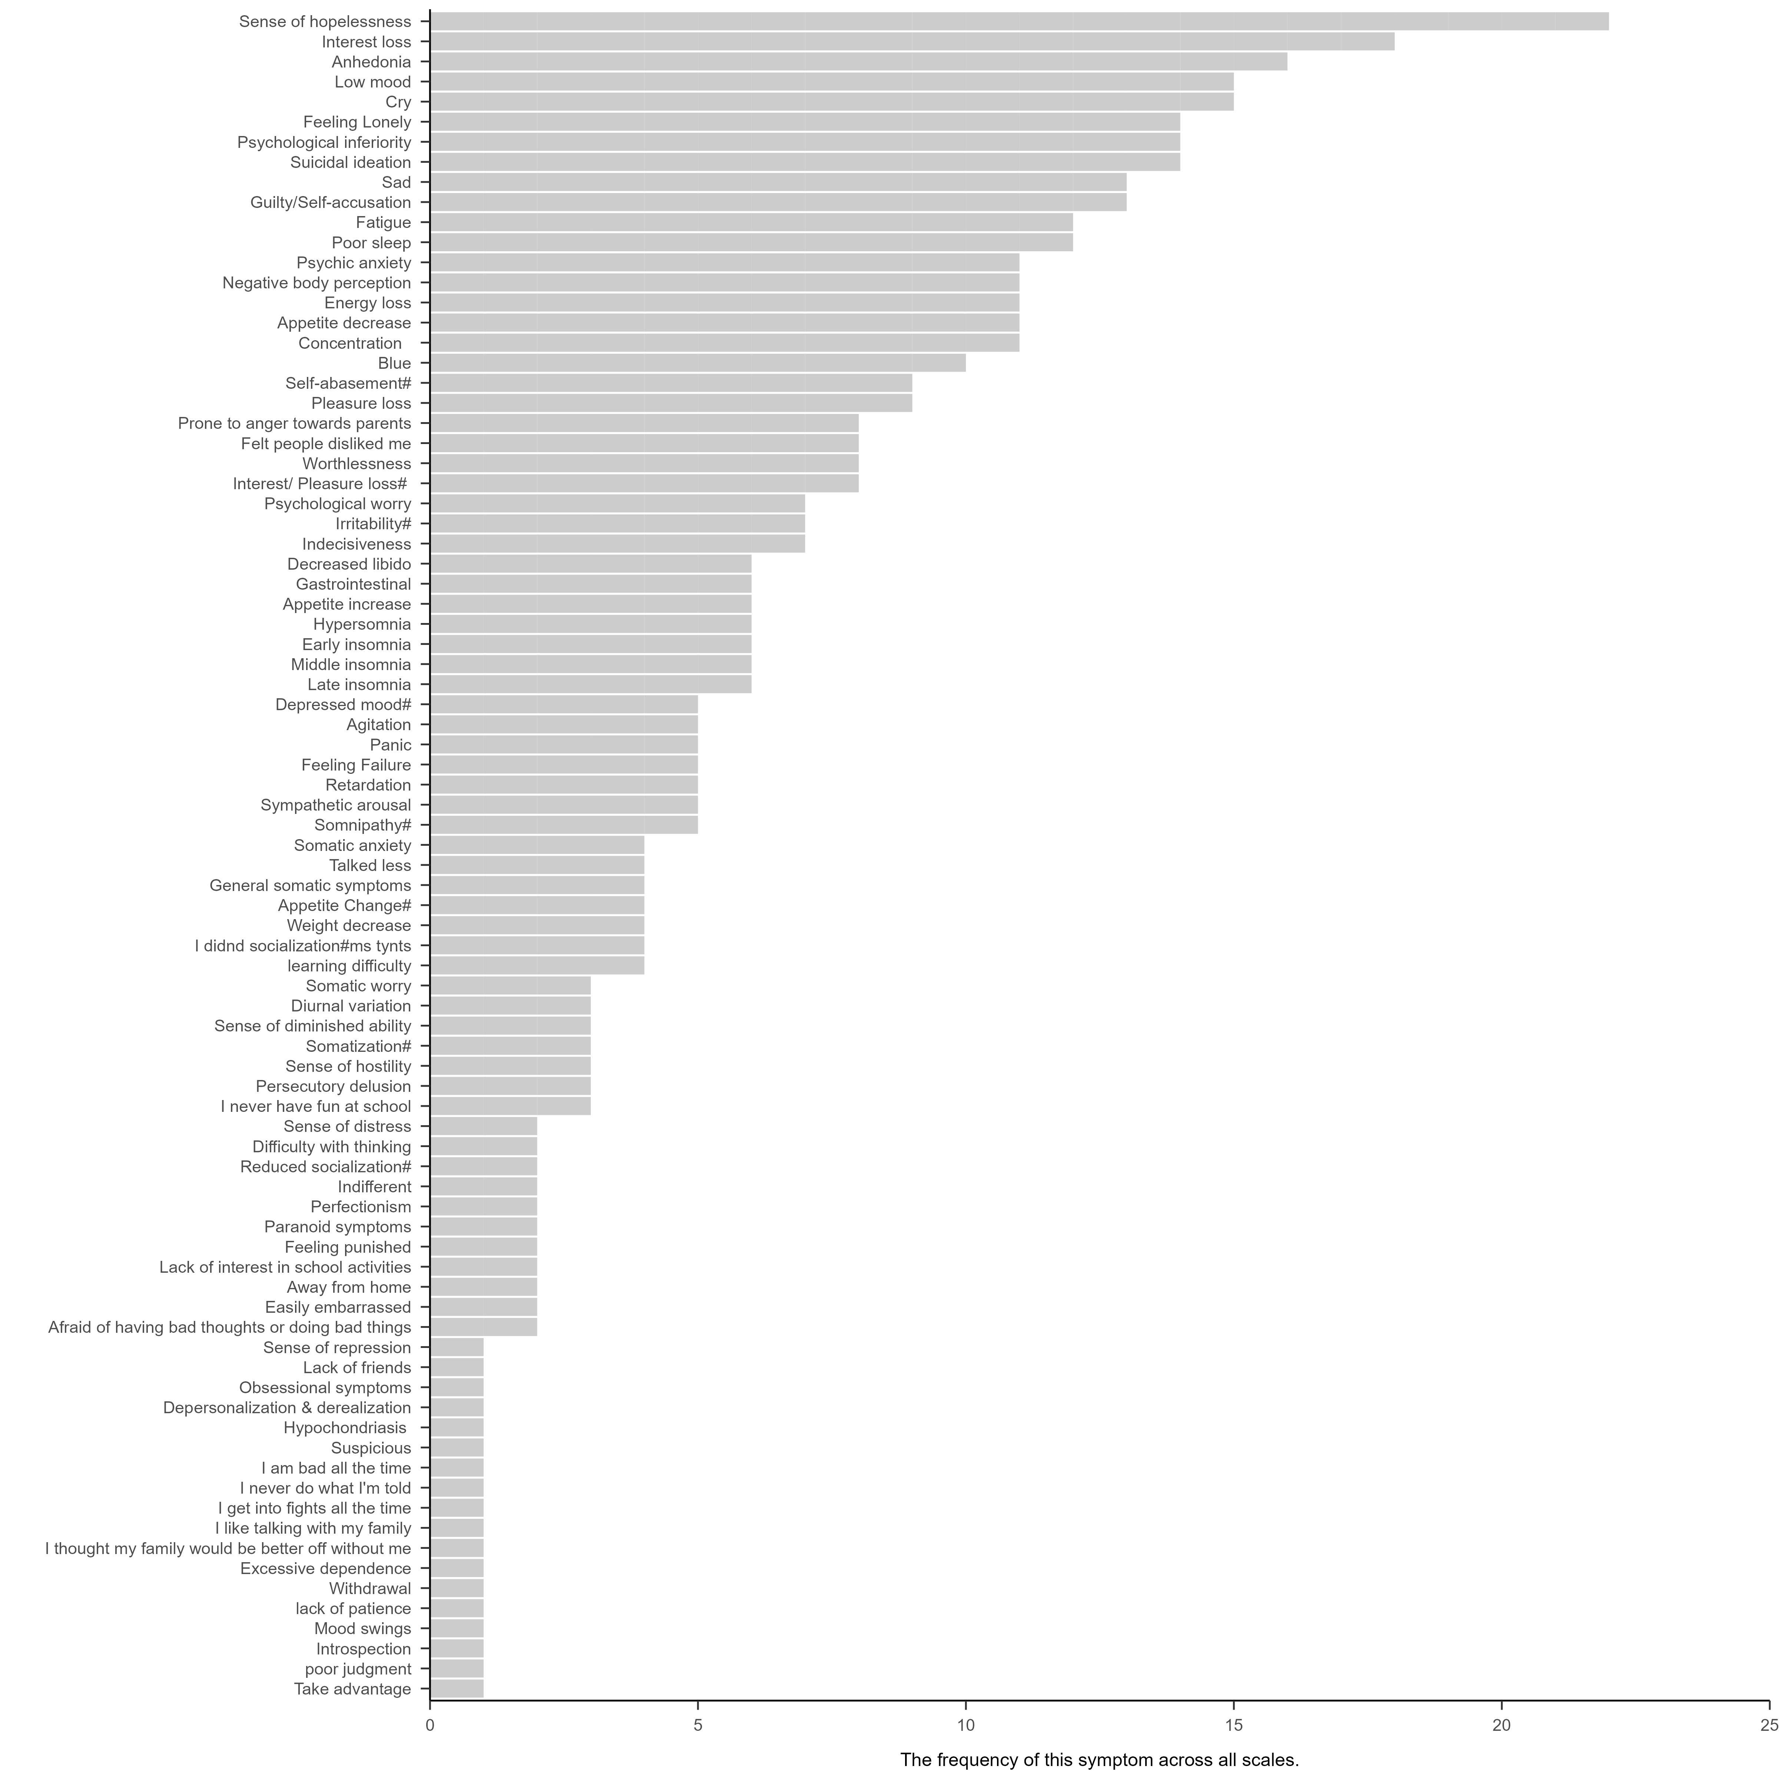

**Figure 4**

*Number of symptoms that appear across combinations of scales.* There are 18 symptoms that appear only in one scale; these symptoms are referred to as idiosyncratic symptoms.

The degree of overlap between scales was calculated using the Jaccard coefficient. The mean overlap across all scales was 0.19, range from 0.09 to 0.25, indicating a very low level of similarity between these scales (see Figure 5). CES-D has the highest average degree of overlap with other scale. The highest overlap, 0.75, appeared between two versions of CES-D: CES-D for adults and CES-D-C for chidlren. The second highest overlap, 0.72, was between DSI and SDS. Many scales that have no overlap with each other. For example, there was no overlap between China Education Panel Survey with Middle-school students Mental Health Scale, PHQ-9, CSSDS, SMFQ, CSSMHS. Note that because Ji_2005 has only one item that measures two symptoms, it has no overlap with PHQ-9, KADS-11.

We found a correlation between the mean Jaccard coefficient of each scale and the scale length, *r* = 0.57, 95% CI [0.29, 0.74]. Similarly, the correlation between mean overlap of scales and the number of captured symptoms is *r* = 0.69, 95% CI [0.48, 0.82]. These findings suggests that longer scales exhibit increased overlap with other scales, thus demonstrating enhanced representativeness.

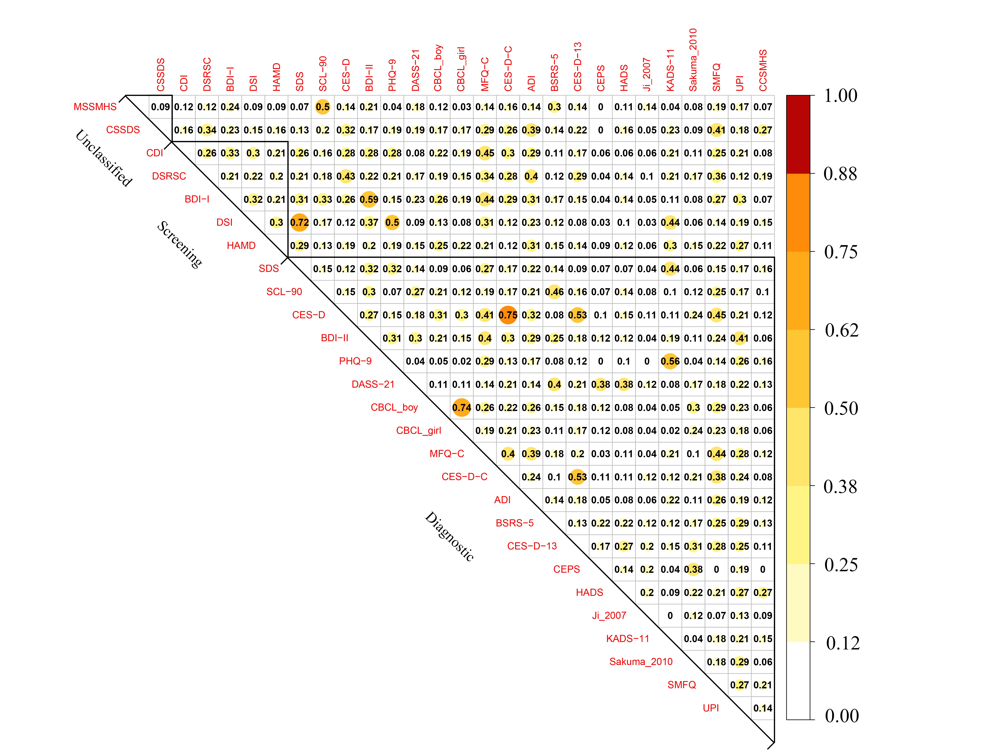

**Figure 5.** *Overlap of item content of 27 depression scales.* ADI: Adolescent Depression Inventory, CDI: Children's Depression Inventory, HAMD: Hamilton Depression Rating Scale for Depression, DSI: Depression Status Inventory, SDS: Self- Rating Depression Scale, MFQ-C: Mood and Feelings Questionnaire, CBCL: Child Behavior Checklist, BDI-II：Beck Depression Inventory-II, DSRSC: Depression Self-rating Scale for Children, BDI-I: Beck Depression Inventory, KADS-11: Kutcher Adolescent Depression Scale, CES-D: The Center for Epidemiological Studies Depression Scale, PHQ-9: Patient Health Questionnaire-9 items, CSSDS: China Middle school students' depression scale, CES-D-C: Center for Epidemiologic Studies Depression Scale for Children, UPI: University Personality Inventory, SMFQ: Short Mood and Feelings Questionnaire, SCL-90: Symptom Checklist 90, CES-D-13: Short version of Center for Epidemiologic Studies Depression Scale, CCSMHS: Chinese College Student Mental Health Scale, DASS-21: The Depression Anxiety Stress Scale, BSRS-5: Brief Symptom Rating Scale, Sakuma_2010: Sakuma et al.(2010) self-designed questionnaire, MSSMHS: Middle-school students Mental Health Scale, CEPS: China Education Panel Survey, HADS: Hospital Anxiety and Depression Scale, Ji_2007: Comprehensive Survey Report on Health-Related/Risk Behaviors among Chinese Adolescents. Mean overlap is detailed in the supplementary materials.

# 4 讨论

[第一段: 总结结果]

研究分析了多个常用的抑郁量表，并发现它们在捕捉抑郁症状方面存在较大的异质性。这些量表之间的项目内容重叠度较低。这对于使用和解释相关数据有重要的启示作用。

[第二段: 与已有研究进行比较]

Fried (2017).的研究中Ces-d与其他量表有着最差的平均重叠率（0.27），而Ces-d在本研究中表现出最高的平均重叠率（0.25），可能是由于：1、本研究中除Ces-d以外还纳入了Ces-d简版以及Ces-d儿童版。2、在他的研究中Ces-d有33%的独特症状，而本研究中，随着纳入的量表增加，Ces-d的独特症状为0。

[第三段: 重新阐述问题的严重性，尤其是与大规模调查进行结合]

抑郁量表的异质性来源可能是由于构念的不清晰，因此，在合并来自不同量表的研究结果时（例如元分析），特别是那些几乎没有重叠的量表时，可能不明智。目前仍普遍认为量表可以互相替代，研究结果表明量表之间异质性非常强。因此在推广结果中应该强调这是某个量表的结果。

[第四段：如何解读结果，call for better standards]

不能认为低重叠就是糟糕的量表，高重叠就是好的量表。选择测量工具时应考虑多种因素，并根据评估的目的和目标进行选择。

[第五段: 展望未来]

**参 考 文 献**

于晓琪, 张亚利, 俞国良. (2022). 2010～2020中国内地高中生心理健康问题检出率的元分析. *心理科学进展*, *30*(05), 978-990.

黄潇潇, 张亚利, 俞国良. (2022). 2010～2020中国内地小学生心理健康问题检出率的元分析. *心理科学进展*, *30*(05), 953-964.

张亚利, 靳娟娟, 俞国良. (2022). 2010～2020中国内地初中生心理健康问题检出率的元分析. *心理科学进展*, *30*(05), 965-977.

陈雨濛, 张亚利, 俞国良. (2022). 2010～2020中国内地大学生心理健康问题检出率的元分析. *心理科学进展*, *30*(05), 991-1004.

汪向东等. (1999). *心理卫生评定量表手册*. 中国心理卫生杂志社.

章婕, 吴振云, 方格, 李娟, 韩布新, 陈祉妍. (2010). 流调中心抑郁量表全国城市常模的建立. *中国心理卫生杂志*, *24*(02), 139-143.

Gu, J., & Chen, S. (2020). Association between active travel to school and depressive symptoms among early adolescents. *Children*, *7*(5), 41.

季成叶. (2007). *中国青少年健康相关/危险行为调查综合报告-2005*. 北京大学医学出版社.

张明园. (1998). *精神科评定量表手册*. 湖南科学技术出版社.

陈姜, 张德甫, 吴敏, 胡巧云, 徐俊娥, 付喜成. (2000). 中学生焦虑情绪调查. *中国校医*(04), 257-258.

Jordan, K. M., Ayers, P. M., Jahn, S. C., Taylor, K. K., Huang, C., Richman, J., & Jason, L. A. (2000). Prevalence of fatigue and chronic fatigue syndrome-like illness in children and adolescents. *Journal of Chronic Fatigue Syndrome*, *6*(1), 3-21.

王汝展, 刘兰芬, 葛红敏, 韩建波. (2009). ZUNG氏抑郁自评量表(SDS)作为外科住院患者抑郁障碍常规筛查工具的可行性研究. *精神医学杂志*, *22*(04), 251-253.

Zung, W. W. (1965). A self-rating depression scale. *Archives of General Psychiatry*, *12*(1), 63-70.

任艳峰, 翟强, 王素珍. (2015). 初中生睡眠质量与肥胖的相关性分析. *中国学校卫生*, *36*(09), 1316-1318.

苏春燕, 张洪君, 王宜芝. (2003). 癌症末期病人家属感受和需求的调查. *护理研究*(09), 519-520.

张作记. (2005). *行为医学量表手册*. 行为医学量表手册.

姚树桥, 孙学礼. (2008). *医学心理学.第5版*. 医学心理学.第5版.

戴晓阳. (2010). *常用心理评估量表手册*. 人民军医出版社.

王俊, 金岳龙, 陈燕, 余结根, 贺连平, 姚应水. (2013). 医学院校大学生抑郁情绪与生活事件的相关分析. *皖南医学院学报*, *32*(02), 151-153.

崔庆霞, 王在翔. (2014). 大学生抑郁现状调查及影响因素研究. *中国卫生事业管理*, *31*(08), 629-630.

段泉泉, 胜利. (2012). 焦虑及抑郁自评量表的临床效度. *中国心理卫生杂志*, *26*(09), 676-679.

郑世华, 仝巧云, 郑爱军. (2016). 大学生抑郁和焦虑状况调查及相关因素分析. *重庆医学*, *45*(20), 2835-2837.

王征宇, 迟玉芬. (1984). 抑郁自评量表(SDS). *上海精神医学*(02), 71-72.

张明园等. (2015). *精神科评定量表手册*. 湖南科学技术出版社.

Zung, W. W. (1969). A cross-cultural survey of symptoms in depression. *American Journal of Psychiatry*, *126*(1), 116-121.

崔杰诚, 陈国生. (1998). 《心理卫生与精神科评定量表》专辑. *健康心理学杂志*, *６*(10), 140-141.

戴海崎, 张锋, 陈雪枫. (2007). *心理与教育测量: 修订版*. 广州: 暨南大学出版社.

仲稳山. (2009). *心理诊断学*. 苏州: 苏州大学出版社.

王征宇. (1984). 症状自评量表(SCL-90). *上海精神医学*(02), 68-70.

高成阁, 王友平, 亢万虎, 张西生, 李强, 方明,... 何瑞嫦. (1997). 陕西省大中学生心理健康水平调查. *中国临床心理学杂志*(01), 42-43.

Derogatis, L. R., Rickels, K., & Rock, A. F. (1976). The SCL-90 and the MMPI: A step in the validation of a new self-report scale. *The British Journal of Psychiatry*, *128*(3), 280-289.

陈树林, 李凌江. (2003). SCL-90信度效度检验和常模的再比较. *中国神经精神疾病杂志*(05), 323-327.

黄赐英, 裴利华. (2005). 大学新生SCL—90调查结果与分析. *株洲师范高等专科学校学报*(03), 29-32.

陈国鹏. (2005). *心理测验与常用量表*. 上海: 上海科学普及出版社.

Mensah, F. K., & Kiernan, K. E. (2010). Parents’ mental health and children’s cognitive and social development: families in England in the Millennium Cohort Study. *Social Psychiatry and Psychiatric Epidemiology*, *45*, 1023-1035.

金华, 吴文源, 张明园. (1986). 中国正常人SCL-90评定结果的初步分析. *中国神经精神疾病杂志*(05), 260-263.

Derogatis, L. R. (1973). SCL-90: an outpatient psychiatric rating scale-preliminary report. *Psychopharmacol Bull*, *9*, 13-28.

Derogatis, L. R. (1977). *The SCL‐90: Administration, Scoring and Procedures Manual*. Baltimore, MD, USA: John Hopkins University Press.

Hoffmann, N. G., & Overall, P. B. (1978). Factor structure of the SCL-90 in a psychiatric population. *Journal of Consulting and Clinical Psychology*, *46*(6), 1187.

史从戎, 张曼华, 王宇, 来源, 高保兴, 乔晓春. (2011). 我国部分农村地区受艾滋病影响儿童心理弹性的保护性因素研究. *中国儿童保健杂志*, *19*(01), 10-12.

Radloff, L. S. (1991). The use of the Center for Epidemiologic Studies Depression Scale in adolescents and young adults. *Journal of Youth and Adolescence*, *20*(2), 149-166.

Cheng, C., Yen, C., Ko, C., & Yen, J. (2012). Factor structure of the center for epidemiologic studies depression scale in Taiwanese adolescents. *Comprehensive Psychiatry*, *53*(3), 299-307.

Lee, S. W., Stewart, S. M., Byrne, B. M., Wong, J. P., Ho, S. Y., Lee, P. W., & Lam, T. H. (2008). Factor structure of the Center for Epidemiological Studies Depression scale in Hong Kong adolescents. *Journal of Personality Assessment*, *90*(2), 175-184.

Cheung, C., & Bagley, C. (1998). Validating an American scale in Hong Kong: the center for epidemiological studies depression scale (CES-D). *The Journal of Psychology*, *132*(2), 169-186.

陈祉妍, 杨小冬, 李新影. (2009). 流调中心抑郁量表在我国青少年中的试用. *中国临床心理学杂志*, *17*(04), 443-445.

Wang, M., Armour, C., Wu, Y., Ren, F., Zhu, X., & Yao, S. (2013). Factor structure of the CES‐D and measurement invariance across gender in mainland Chinese adolescents. *Journal of Clinical Psychology*, *69*(9), 966-979.

Yang, L., Jia, C., & Qin, P. (2015). Reliability and validity of the Center for Epidemiologic Studies Depression Scale (CES-D) among suicide attempters and comparison residents in rural China. *BMC Psychiatry*, *15*(1), 1-8.

Radloff, L. S. (1977). The CES-D scale: A self-report depression scale for research in the general population. *Applied Psychological Measurement*, *1*(3), 385-401.

潘丝媛, 李武权, 黎明, 郭蓝, 邓雪清, 卢次勇. (2018). 广州市中学生网络成瘾与自杀相关行为的关系. *中国学校卫生*, *39*(02), 229-231.

Jiang, L., Wang, Y., Zhang, Y., Li, R., Wu, H., Li, C., ... Tao, Q. (2019). The reliability and validity of the center for epidemiologic studies depression scale (CES-D) for Chinese university students. *Frontiers in Psychiatry*, *10*, 315.

刘平. (1999). 流调中心用抑郁量表（Center for Epidemiological Studies Depression Scale，CES-D）. *中国心理卫生杂志（增刊）*, 200-202.

刘琰, 谭曦, 李扬, 徐芳, 张杰, 孔军辉. (2015). 大学生抑郁情绪现状及影响因素分析. *中华全科医学*, *13*(01), 91-93.

Kovacs, M. (1992). Children’s depression inventory. *Acta Paedopsychiatrica: International Journal of Child & Adolescent Psychiatry*.

Beck, A. T., Ward, C. H., Mendelson, M., Mock, J., & Erbaugh, J. (1961). An inventory for measuring depression. *Archives of General Psychiatry*, *4*(6), 561-571.

洪忻, 李解权, 梁亚琼, 王志勇, 徐斐. (2012). 儿童抑郁量表中文版在中学生中的信效度分析. *中国学校卫生*, *33*(10), 1182-1185.

陈海燕, 姚树桥, 明庆森, 侯婵娟. (2012). 中学生的抑郁症状与生活事件:非适应性策略的中介作用. *中国心理卫生杂志*, *26*(10), 786-790.

俞大维, 李旭. (2000). 儿童抑郁量表(CDI)在中国儿童中的初步运用. *中国心理卫生杂志*(04), 225-227.

吴文峰, 卢永彪, 谭芙蓉, 姚树桥. (2010). 儿童抑郁量表中文版在中小学生中的信效度. *中国心理卫生杂志*, *24*(10), 775-779.

Samm, A., Värnik, A., Tooding, L., Sisask, M., Kolves, K., & Von Knorring, A. (2008). Children’s depression inventory in Estonia: single items and factor structure by age and gender. *European Child & Adolescent Psychiatry*, *17*, 162-170.

Kovas, M. (1985). The Children's Depression Inventory (CDI). *Psychological Bulletin*, *21*, 995-998.

苏林雁, 王凯, 朱焱, 罗学荣, 杨志伟, 儿童抑郁量表全国协作组. (2003). 儿童抑郁障碍自评量表的中国城市常模. *中国心理卫生杂志*(08), 547-549.

王凯, 苏林雁, 朱焱, 翟静, 杨志伟, 张纪水. (2002). 儿童焦虑性情绪障碍筛查表的中国城市常模. *中国临床心理学杂志*(04), 270-272.

周德新. (2006). 大学生自杀现象的社会学解读. *湖南文理学院学报(社会科学版)*(05), 60-62.

Beck, A. T., & Beck, R. W. (1972). Screening depressed patients in family practice. A rapid technic. *Postgrad Med*, *52*(6), 81-85. doi: 10.1080/00325481.1972.11713319

Beck, A. T., Steer, R. A., & Carbin, M. G. (1988). Psychometric properties of the Beck Depression Inventory: Twenty-five years of evaluation. *Clinical Psychology Review*, *8*(1), 77-100.

Beck, A. T., & Beamesderfer, A. (1974). *Assessment of depression: the depression inventory.*: S. Karger.

王极盛, 李焰, 赫尔实. (1997). 中国中学生心理健康量表的编制及其标准化. *社会心理科学*(04), 17-22.

王极盛. (1998). *心灵时代*. 中国城市出版社.

杨文辉, 刘绍亮, 周烃, 彭芳, 刘细梅, 李莉,... 蚁金瑶. (2014). 贝克抑郁量表第2版中文版在青少年中的信效度. *中国临床心理学杂志*, *22*(02), 240-245.

王振, 苑成梅, 黄佳, 李则挚, 陈珏, 张海音,... 肖泽萍. (2011). 贝克抑郁量表第2版中文版在抑郁症患者中的信效度. *中国心理卫生杂志*, *25*(06), 476-480.

Wang, D., Ou, C., Chen, M., & Duan, N. (2009). Health-promoting lifestyles of university students in Mainland China. *BMC Public Health*, *9*(1), 1-9.

Dere, J., Watters, C. A., Yu, S. C., Bagby, R. M., Ryder, A. G., & Harkness, K. L. (2015). Cross-cultural examination of measurement invariance of the Beck Depression Inventory–II. *Psychological Assessment*, *27*(1), 68.

Spitzer, R. L., Kroenke, K., Williams, J. B., Patient, H. Q. P. C., & Patient, H. Q. P. C. (1999). Validation and utility of a self-report version of PRIME-MD: the PHQ primary care study. *Jama*, *282*(18), 1737-1744.

Kroenke, K., & Spitzer, R. L. (2002). The PHQ-9: a new depression diagnostic and severity measure. *Psychiatric Annals*, *32*(9), 509-515.

Sun, X. Y., Li, Y. X., Yu, C. Q., & Li, L. M. (2017). Reliability and validity of depression scales of Chinese version: a systematic review. *Zhonghua Liu Xing Bing Xue Za Zhi= Zhonghua Liuxingbingxue Zazhi*, *38*(1), 110-116.

苑新群. (2014). *大学生媒体多任务与心理健康的关系*. 首都师范大学.

Lovibond, P. F., & Lovibond, S. H. (1995). The structure of negative emotional states: Comparison of the Depression Anxiety Stress Scales (DASS) with the Beck Depression and Anxiety Inventories. *Behaviour Research and Therapy*, *33*(3), 335-343.

龚栩, 谢熹瑶, 徐蕊, 罗跃嘉. (2010). 抑郁-焦虑-压力量表简体中文版(DASS-21)在中国大学生中的测试报告. *中国临床心理学杂志*, *18*(04), 443-446.

苏林雁, 李雪荣, 罗学荣, 万国斌, 杨志伟. (1998). Achenbach儿童行为量表的再标准化及效度检验. *中国心理卫生杂志*(02), 4-6.

忻仁娥. (1994). Achenbach 儿童行为量表( 中国标准化). *上海精神医学*, *4*(1), 1-2.

Achenbach, T., & Edelbrock, C. (1987). *Manual for the Child Behavior Checklist*. Burlington: University of Vermont.

Wood, A., Kroll, L., Moore, A., & Harrington, R. (1995). Properties of the mood and feelings questionnaire in adolescent psychiatric outpatients: a research note. *Journal of Child Psychology and Psychiatry*, *36*(2), 327-334.

曹枫林, 苏林雁, 程培霞. (2009). 情绪问卷中文版用于中学生的信度和效度研究. *中国临床心理学杂志*, *17*(04), 440-442.

王极盛, 邱炳武, 赫尔实. (1997). 中学生抑郁量表的编制及其标准化. *社会心理科学*(3), 3.

William Li, H. C., Chung, O. K. J., & Ho, K. Y. (2010). Center for epidemiologic studies depression scale for children: psychometric testing of the Chinese version. *Journal of Advanced Nursing*, *66*(11), 2582-2591.

Huang, C. Y., & Hsu, W. Y. (2003). A study of developing an adolescent depression inventory. *Journal of Education Psychology*, *26*, 167-190.

楊雅惠. (2003). 依附,負向情緒調適預期和壓力因應對情緒經驗的影響歷程之探討:以大四學生的生涯抉擇壓力為例.

Lee, M., Lee, Y., Yen, L., Lin, M., & Lue, B. (1990). Reliability and validity of using a brief psychiatric symptom rating scale in clinical practice. *Journal of the Formosan Medical Association*, *89*(12), 1081-1087.

Li, L. W., Liu, J., Xu, H., & Zhang, Z. (2016). Understanding rural–urban differences in depressive symptoms among older adults in China. *Journal of Aging and Health*, *28*(2), 341-362.

张宝山, 李娟. (2011). 简版流调中心抑郁量表在全国成年人群中的信效度. *中国心理卫生杂志*, *25*(07), 506-511.

Ma, L., Gao, L., Chiu, D. T., Ding, Y., Wang, W., & Wang, Y. (2020). Depressive symptoms prevalence, associated family factors, and gender differences: a national cohort study of middle school students in China. *Journal of Affective Disorders*, *274*, 545-552.

Zigmond, A. S., & Snaith, R. P. (1983). The Hospital Anxiety and Depression Scale. *Acta Psychiatrica Scandinavica*, *67*(6), 361-370.

汤毓华, 张明园. (1984). 汉密顿抑郁量表(HAMD). *上海精神医学*(02), 61-64.

周慧鸣, 郝楠, 杜亚松, 刘艳玉, 隋雨彤, 王艳华,... KUTCHER Stanley. (2015). 中文版Kutcher青少年抑郁量表测评青少年样本的效度与信度. *中国心理卫生杂志*, *29*(06), 413-418.

Sakuma, K. K., Sun, P., Unger, J. B., & Johnson, C. A. (2010). Evaluating depressive symptom interactions on adolescent smoking prevention program mediators: A mediated moderation analysis. *Nicotine & Tobacco Research*, *12*(11), 1099-1107.

程培霞, 曹枫林, 苏林雁. (2009). 简化情绪量表中文版用于中学生的信度和效度. *中国心理卫生杂志*, *23*(01), 60-62.

Yu, L., & Cai, L. (2007). Review on the application of the University Personality Inventory in China and abroad. *Prof Circle*(53), 158-159.

Huang, Q., Li, Y., Huang, S., Qi, J., Shao, T., Chen, X., ... Cai, Y. (2020). Smartphone use and sleep quality in chinese college students: a preliminary study. Front Psychiatry 11: 1–7.

张华. (2021). *散打运动对大学生心理健康影响的教学实验研究*. 河北师范大学.

刘豫鑫, 刘津, 王玉凤. (2010). 简明儿童少年国际神经精神访谈(父母版)的信效度. *中国心理卫生杂志*, *24*(12), 921-925.

刘豫鑫, 刘津, 王玉凤. (2011). 简明儿童少年国际神经精神访谈儿童版的信效度. *中国心理卫生杂志*, *25*(01), 8-13.

Andresen, E. M., Malmgren, J. A., Carter, W. B., & Patrick, D. L. (1994). Screening for depression in well older adults: Evaluation of a short form of the CES-D. *American Journal of Preventive Medicine*, *10*(2), 77-84.

Kessler, R. C., & Stün, T. B. (2004). The World Mental Health (WMH) Survey Initiative version of the World Health Organization (WHO) CompoundInternational Diagnostic Interview (CIDI). *International Journal of Methods in Psychiatric Research*, *13*(2).

宋维真, 张建平. (1993). *心理健康测查表(PHI)使用指导书*

. 北京：中国科学院心理研究所.

Fried, E. I. (2017). The 52 symptoms of major depression: Lack of content overlap among seven common depression scales. *Journal of Affective Disorders*, *208*, 191-197.

Fried, E. I., & Nesse, R. M. (2015). Depression sum-scores don’t add up: Why analyzing specific depression symptoms is essential. *BMC Medicine*, *13*(1), 72. https://doi.org/10.1186/s12916-015-0325-4